**Web Application Development**

**(CPRG-008-004)**

**Assignments 1 – 6**

**By: Mohamed Ibrahim**

**GitHub Link**

**Azure Link**

**July 2021**

**Assignment 1**

Create a basic information website on the topic of your choice.

Must have:

Homepage

About Page

Contact Page - No form needed. Just add contact details.

404 Page

**Homepage:**

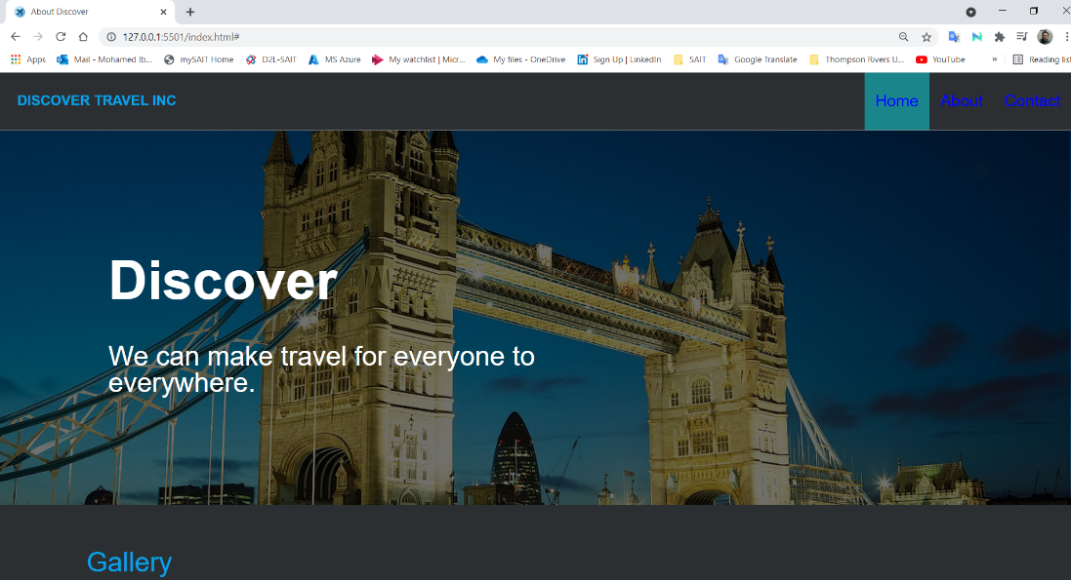

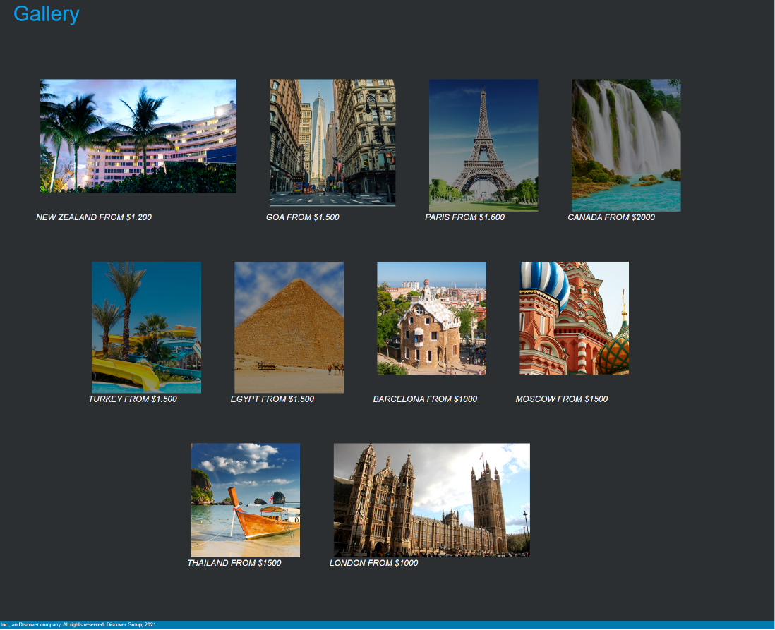

**About page:**

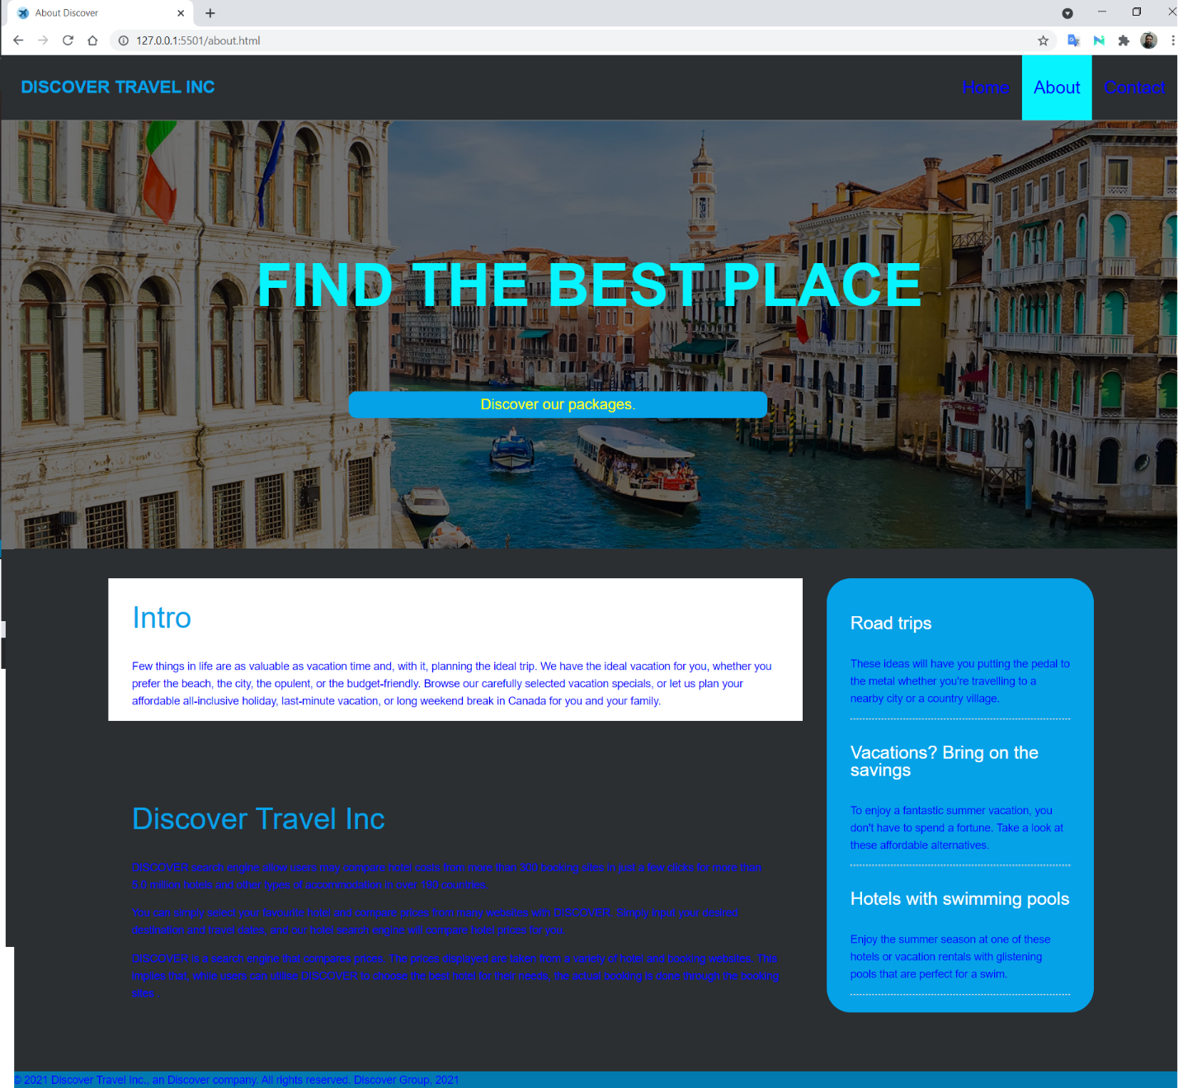

**Contact page:**

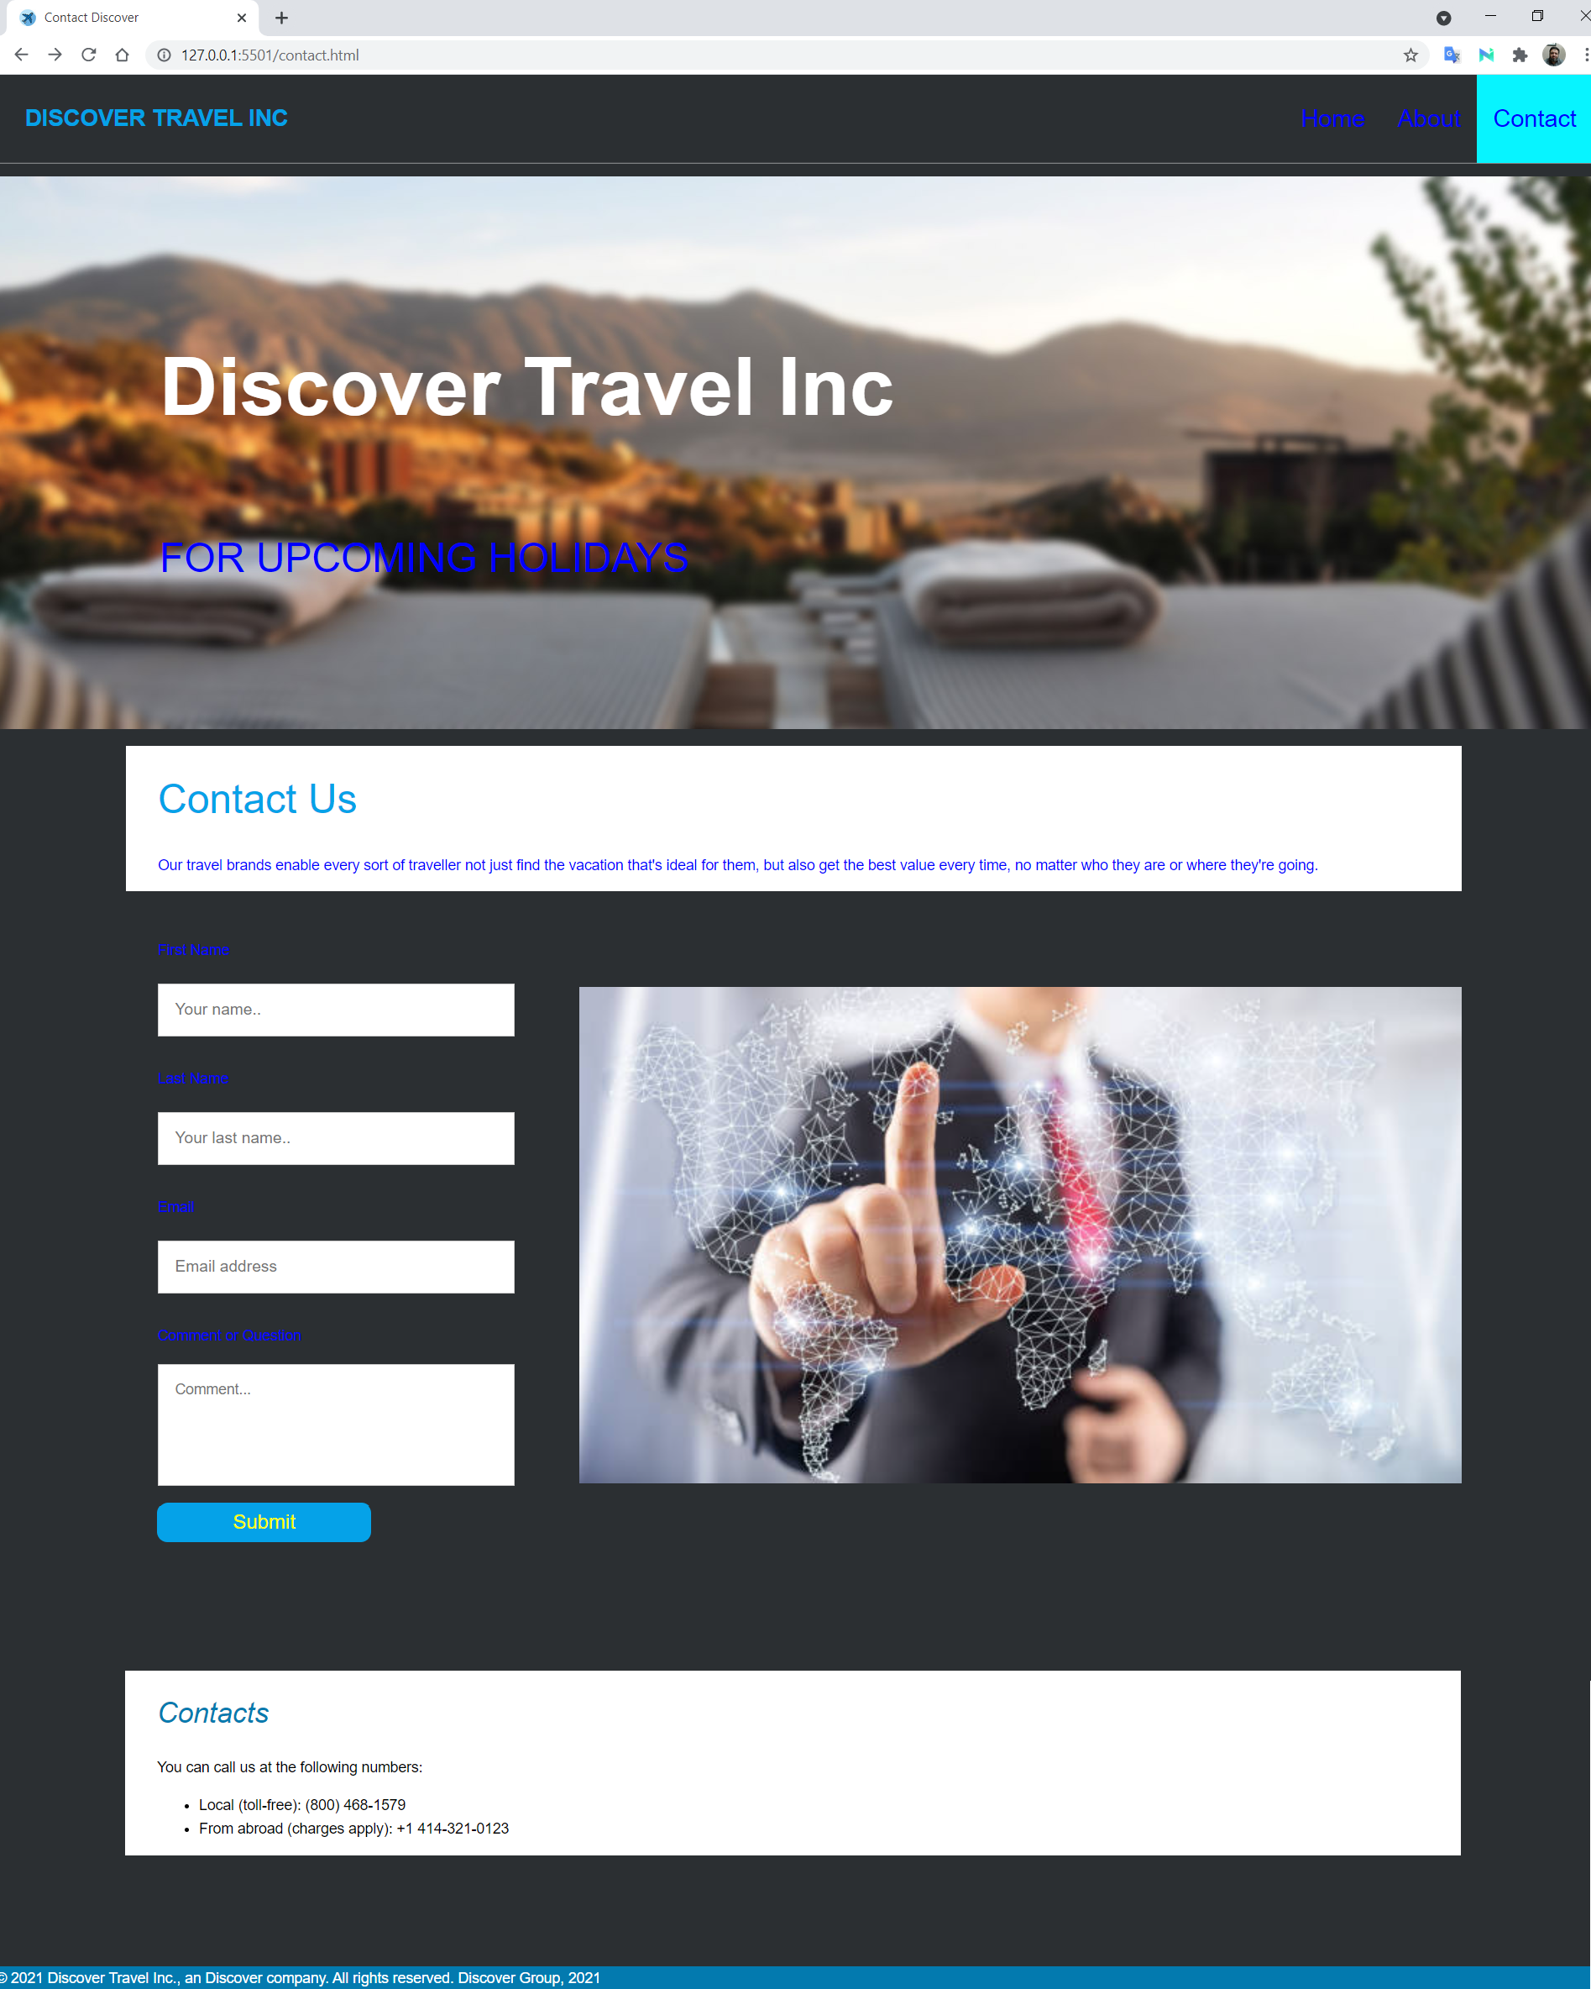

**404 page:**

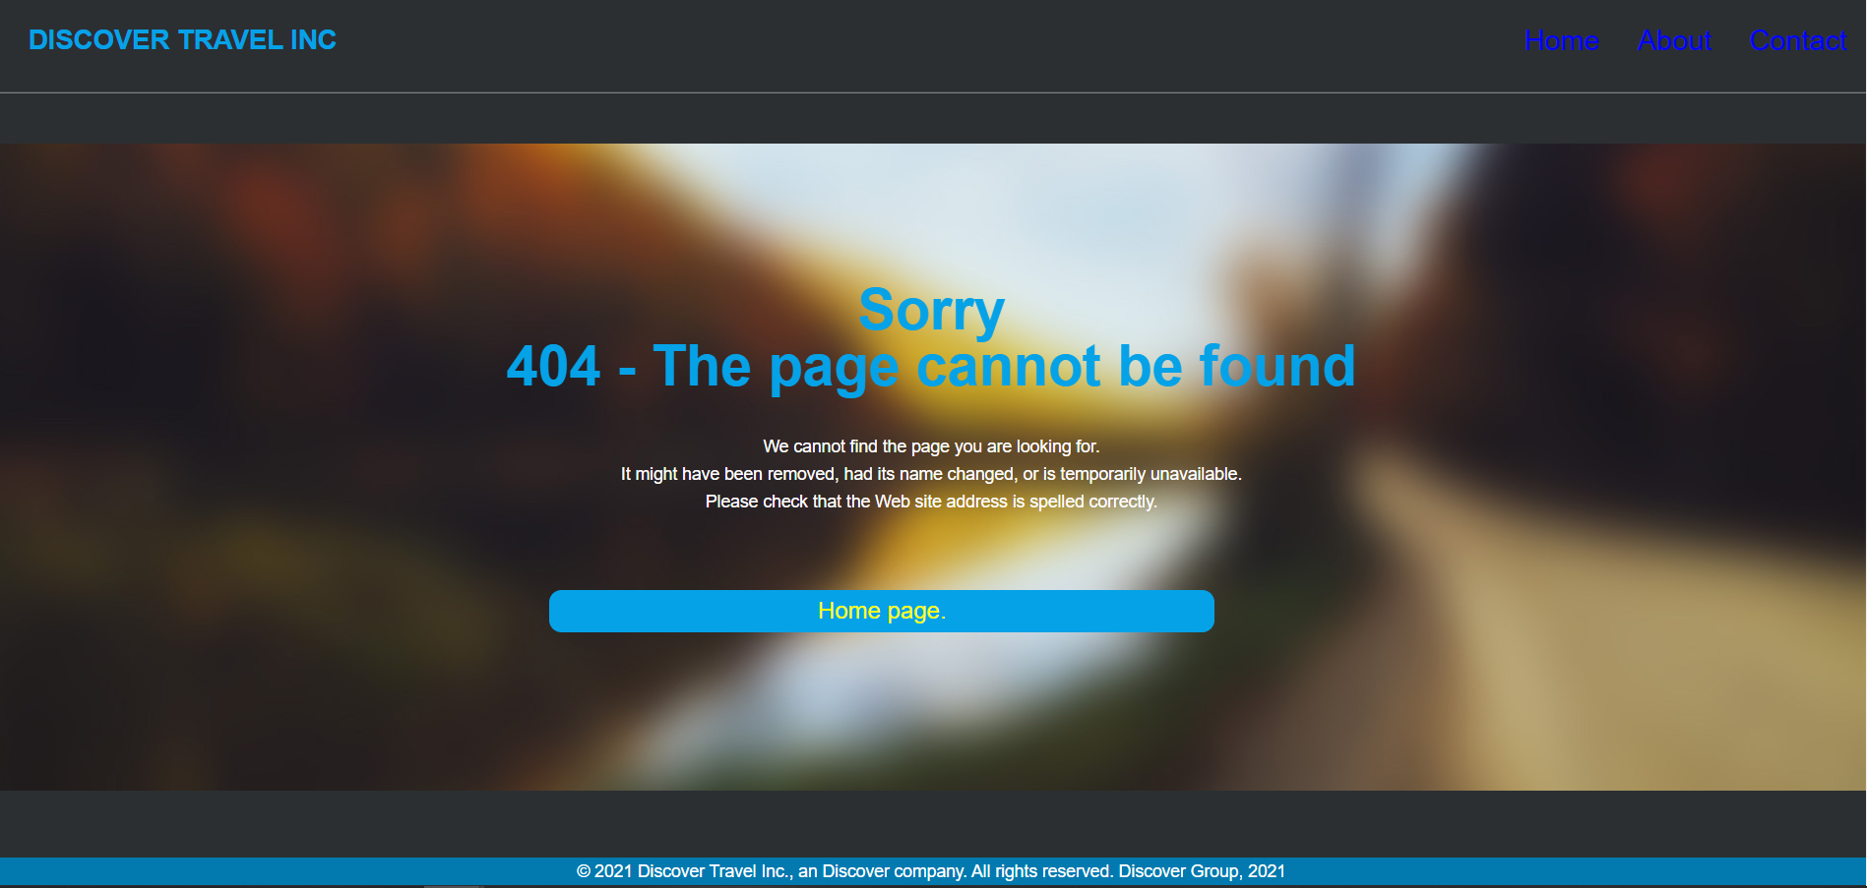

**Assignment 2 : Node Modules**

* Set up Nodemon on your informational website app.
* npm i nodemon --save-dev
* Create a module that returns a random greeting.
* “mfmodule.js”
* //This is my local module to  random greetings with different languages
* let anArrayOfGreetings = [
* "Welcome to our website",
* "أهلا بك في موقعنا",
* "Bienvenue sur notre site",
* "Willkommen auf unserer Webseite",
* "Bienvenido a nuestro sitio web",
* "私たちのウェブサイトへようこそ",
* "Bine ati venit pe site-ul nostru",
* "Benvenuti sul nostro sito web",
* "Καλώς ήρθατε στην ιστοσελίδα μας",
* "Welkom by ons webwerf"
* ];
* let anArrayOfLanguages = ["English","Arabic","French","German","Spanish","Japanese","Romanian","Italian","Greek","Afrikaans"];
* let anArrayOfUniqueNumbers = [];
* let newNumber = 0;
* let numberGenerator = function () {
* if (anArrayOfUniqueNumbers.length >= 10) return;
* newNumber = Math.floor(Math.random() * 10 + 1);
* if (anArrayOfUniqueNumbers.indexOf(newNumber) < 0) {
* anArrayOfUniqueNumbers.push(newNumber);
* }
* numberGenerator(anArrayOfUniqueNumbers);
* return  anArrayOfUniqueNumbers;
* };
* numberGenerator();
* // document.getElementById("myFrame").onload = function(){sendGreeting()}
* function sendGreeting() {
* newNumber = anArrayOfUniqueNumbers[1];
* randGreeting = anArrayOfGreetings[newNumber];
* randLanguage = anArrayOfLanguages[newNumber];
* document.getElementById('greeting').innerHTML = randGreeting;
* document.getElementById('greetingLang').innerHTML = randLanguage;
* return randGreeting;
* }
* function sendLanguage() {
* newNumber = anArrayOfUniqueNumbers[1];
* //console.log(newNumber);
* randLanguage = anArrayOfLanguages[newNumber];
* document.getElementById('greetingLang').innerHTML = randLanguage;
* return randLanguage;
* }
* module.exports.sendGreeting = sendGreeting;
* module.exports.sendLanguage  = sendLanguage;
* Import this module and use it to choose a diﬀerent ﬁlename for the homepage each time the app loads.
* “js.js”
* var greeting = require('mf-module');
* const greetings = greeting.greeting()
* console.log(greetings)
* console.log(greeting.lang())
* //This line to call the greeting function whenever the page is loaded
* function sendGreeting() {
* greeting.sendGreeting();
* greeting.sendLanguage();
* }
* //sendGreeting()
* Website:

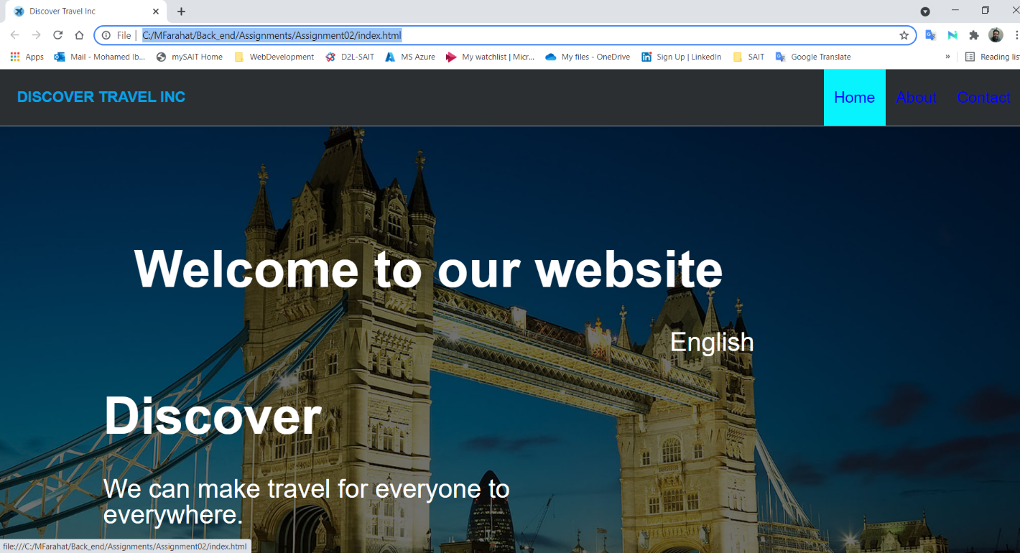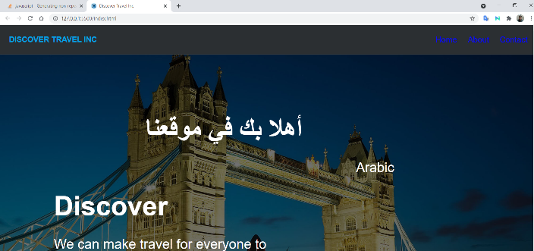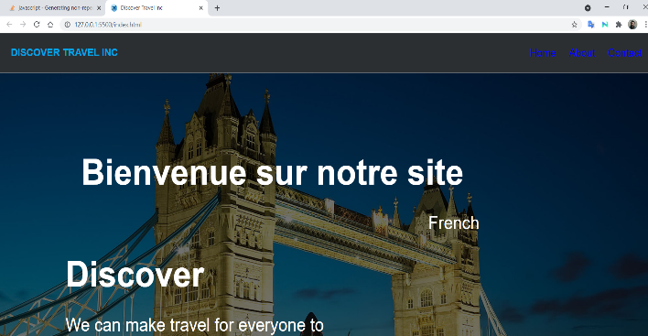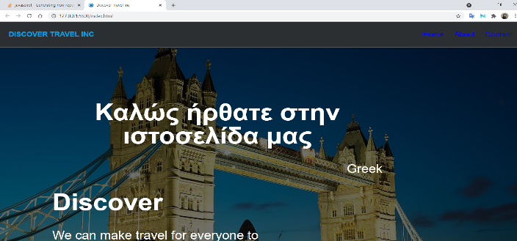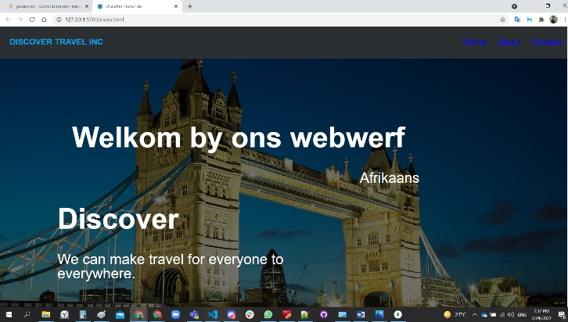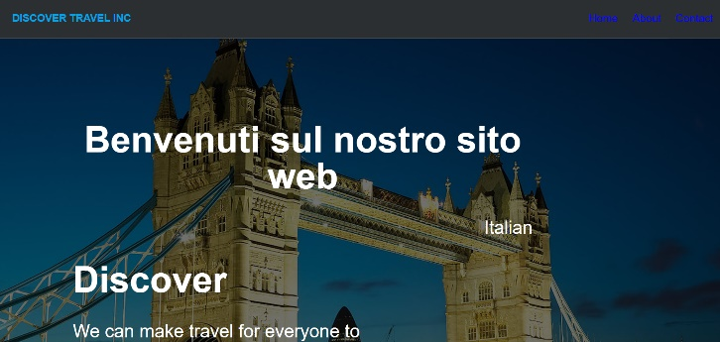

**Assignment 3: Express**

* Rewrite your current informational website using Express.
* npm i express
* “index.js”
* const express = require("express");
* const app = express();
* app.use(express.urlencoded({ extended: true }));
* app.use(express.static("public", {
* extensions: ["html"]}));
* app.get ("/", (req, res) => {
* res.redirect('/index.html')})
* app.use((req, res, next) => {
* res.status(404)
* res.redirect('/e404.html')}) //Redirect to 404 custom page if page is not found
* app.listen(8000, () => { });
* //console.log("Server is listening on port 8000. Ready to accept requests.");

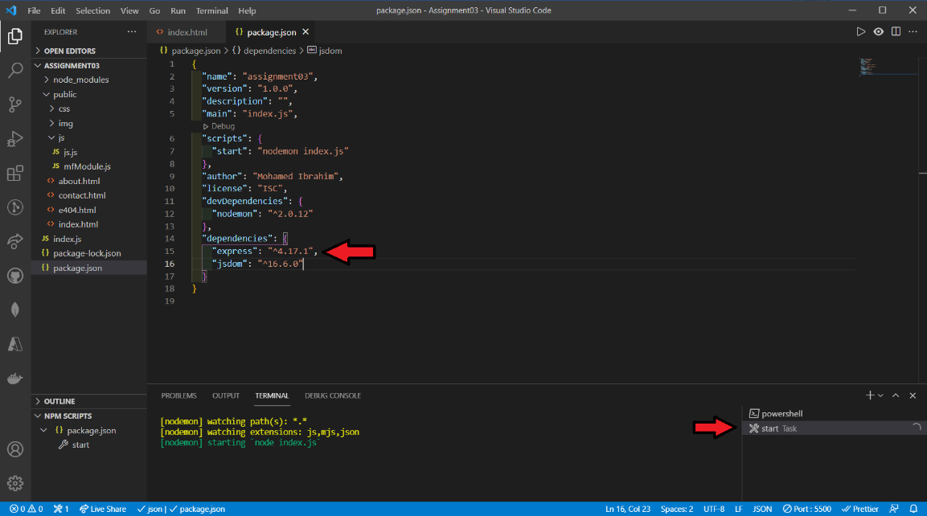

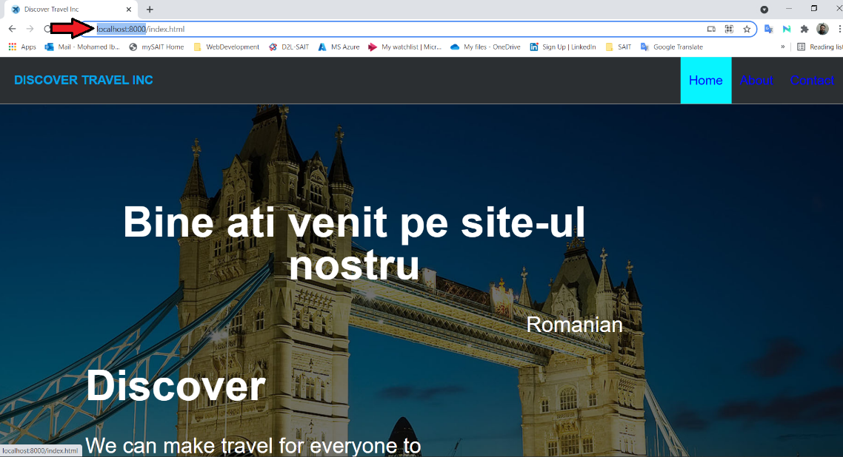

**Assignment 4: Forms and Pug**

* Rewrite your informational website using Pug templates.

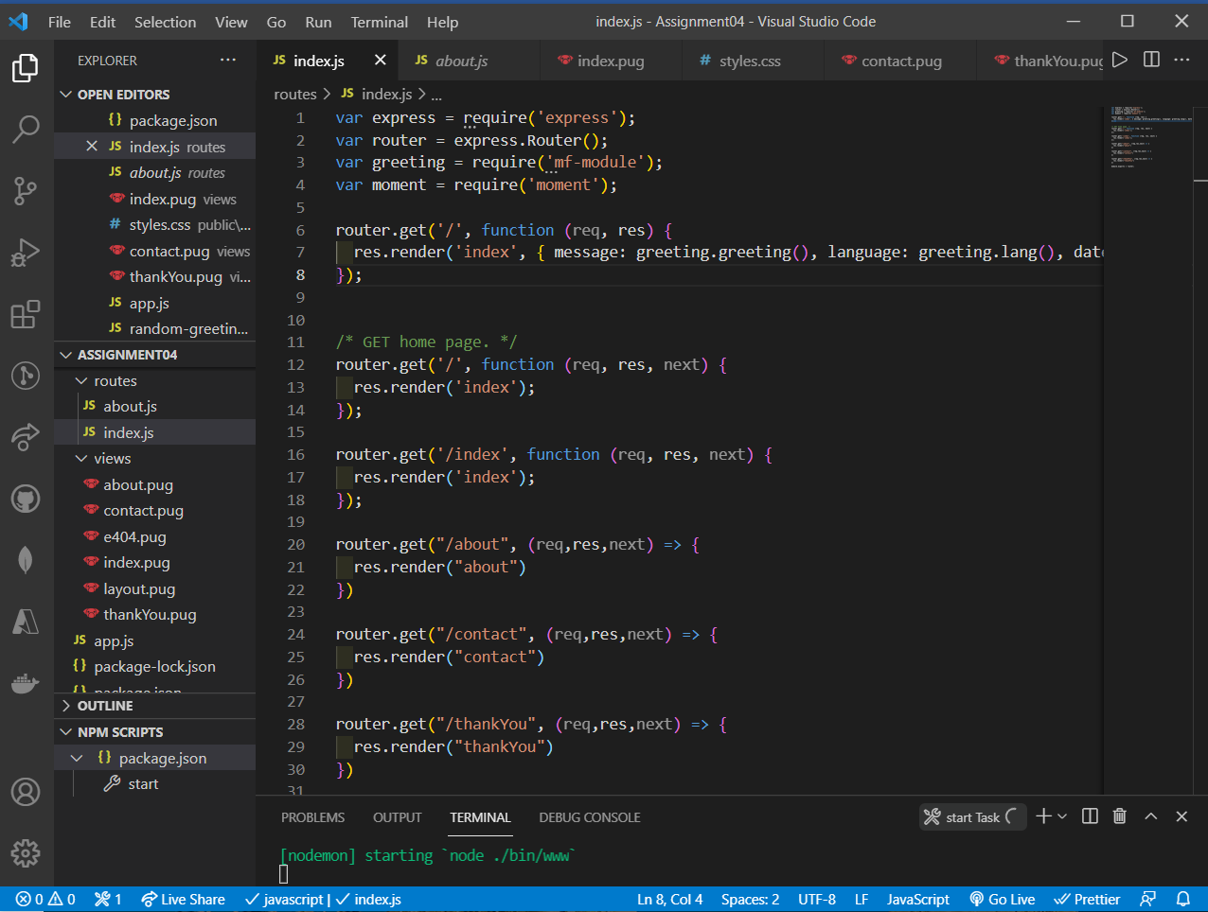

Layout:

doctype html

html

  head

    // Required meta tags

    meta(charset='utf-8')

    meta(name='viewport' content='width=device-width, initial-scale=1')

    // Bootstrap CSS

    link(href='https://cdn.jsdelivr.net/npm/bootstrap@5.0.2/dist/css/bootstrap.min.css' rel='stylesheet' integrity='sha384-EVSTQN3/azprG1Anm3QDgpJLIm9Nao0Yz1ztcQTwFspd3yD65VohhpuuCOmLASjC' crossorigin='anonymous')

    link(rel='stylesheet', href='/stylesheets/style.css')

    link(rel='stylesheet' type='' href='css/styles.css')

    link(href='css/layout.css' rel='stylesheet' type='text/css' media='all')

    link(rel='shortcut icon' type='image/x-icon' href='img/icon.png')

  body

    header#demo-header

      .wrapper.row1

        header#header

          #logo.fl_left

            h1(style='padding: 0px 10px;')

              a(href='/')

                | Discover Travel Inc

                br

          nav(style='color: blue;')

            ul

              li

                a(href='/contact') Contact

              li

                a(href='/about') About

              li

                a(href='/') Home

    block content

    footer

      p(style='color: white;')

        | &copy; 2021 Discover Travel Inc., an Discover company. All rights reserved. Discover Group, 2021

    // Optional JavaScript; choose one of the two!

    script(src='js/js.js')

    script(src='JS/mfModule.js')

    // Option 1: Bootstrap Bundle with Popper

    script(src='https://cdn.jsdelivr.net/npm/bootstrap@5.0.2/dist/js/bootstrap.bundle.min.js' integrity='sha384-MrcW6ZMFYlzcLA8Nl+NtUVF0sA7MsXsP1UyJoMp4YLEuNSfAP+JcXn/tWtIaxVXM' crossorigin='anonymous')

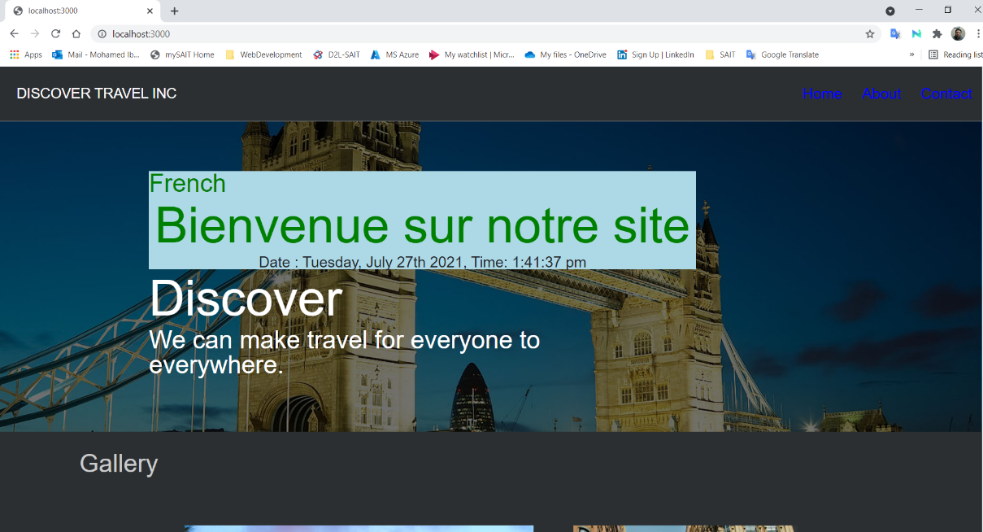

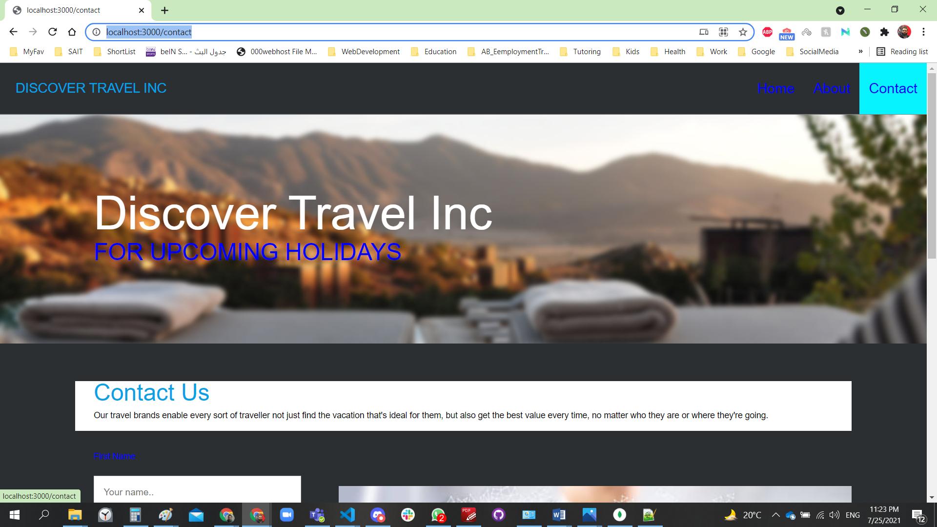

**The form:**

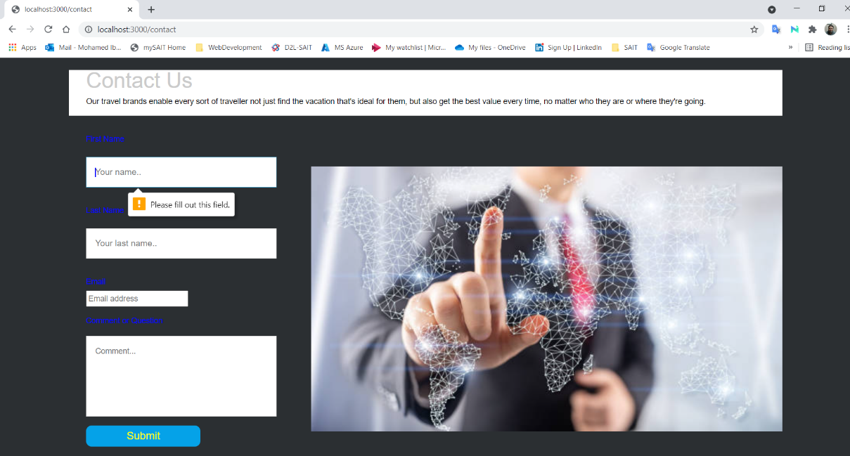

**Thank you, page:**

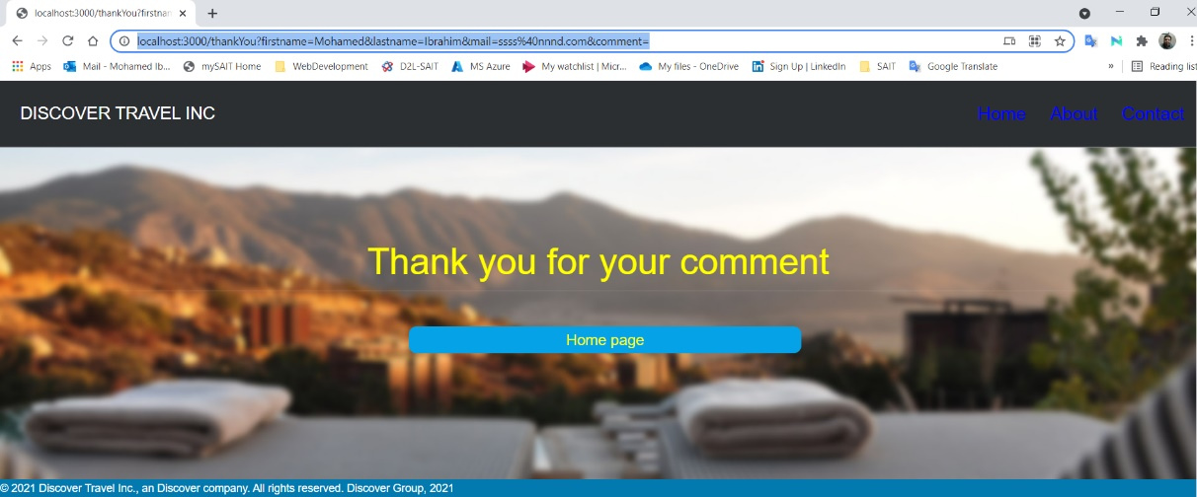

**Error 404 page:**

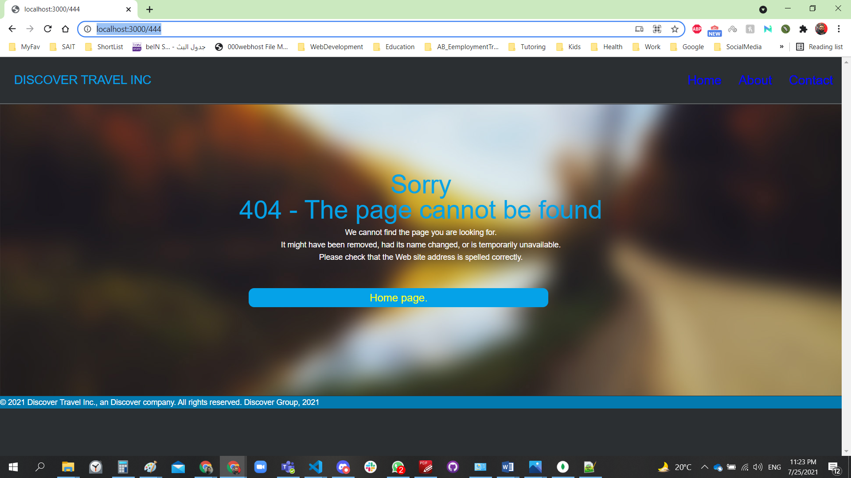

**Assignment 5: Forms and Pug**

* Store information from the contact form on your website in a database.

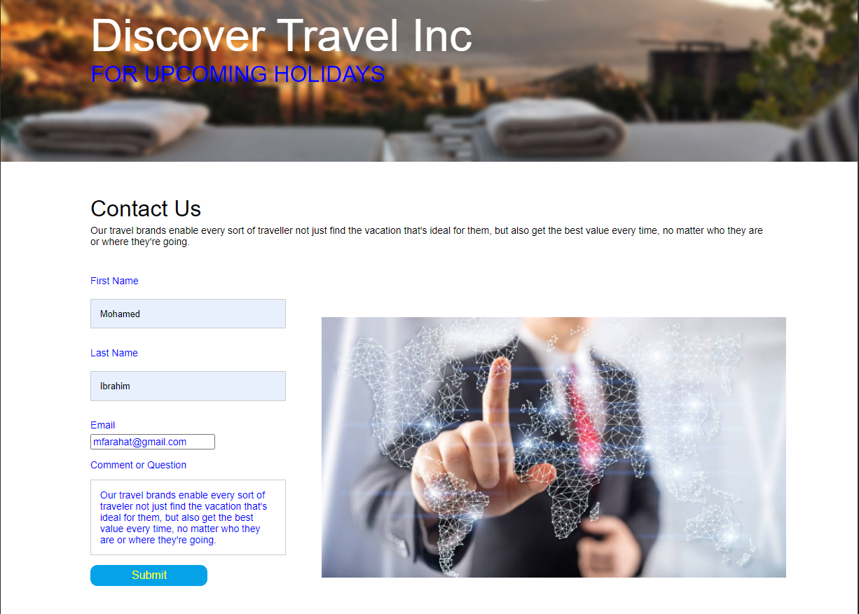

* Find contact information from a particular user and console.log the entire contact form info

to the terminal.

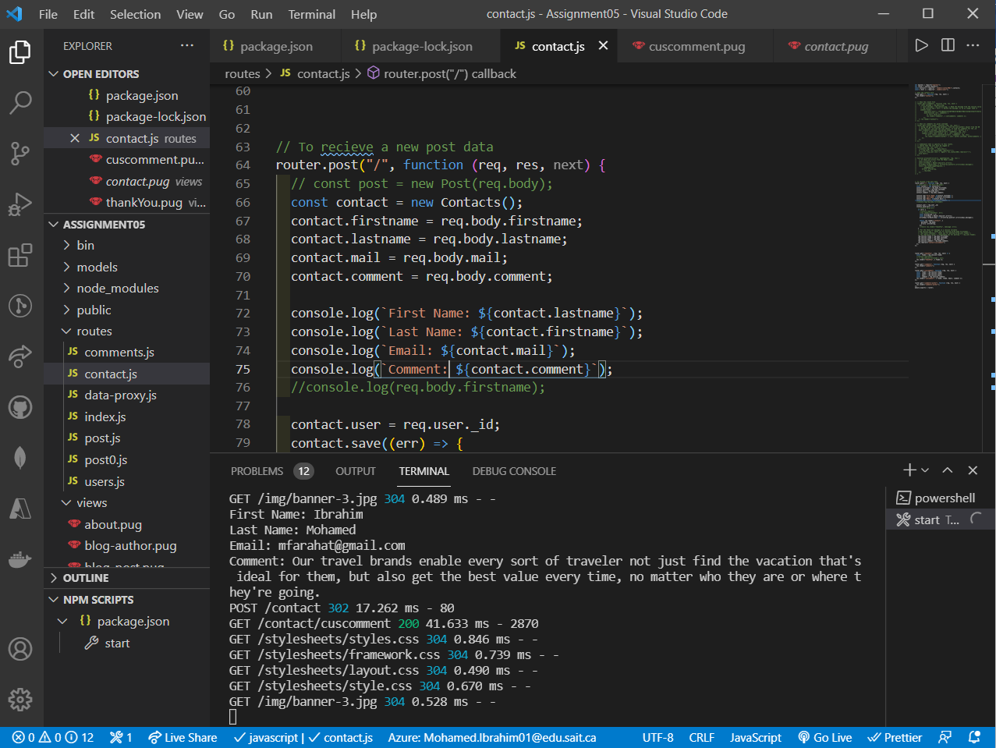

* Try passing in the information to a pug ﬁle and displaying it on the page
* 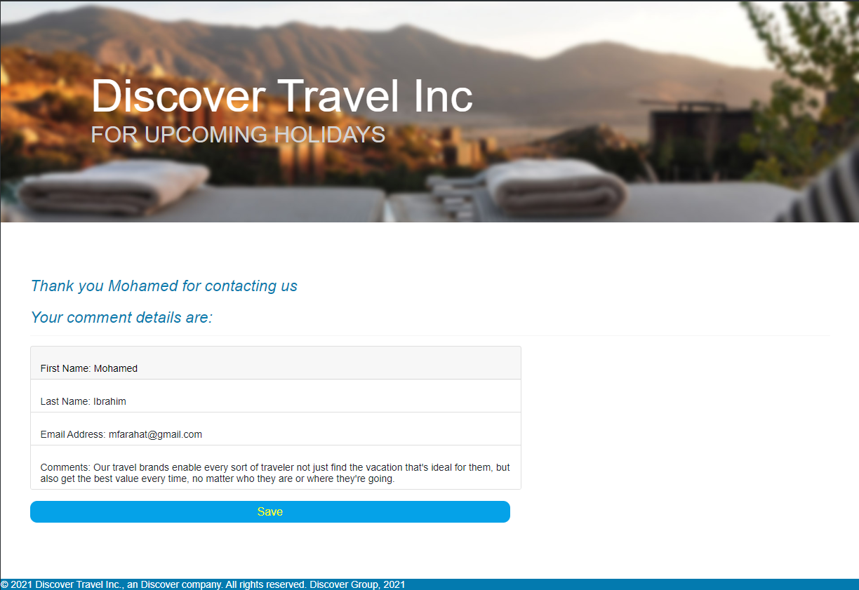
* Play around with Compass to double check your database collections

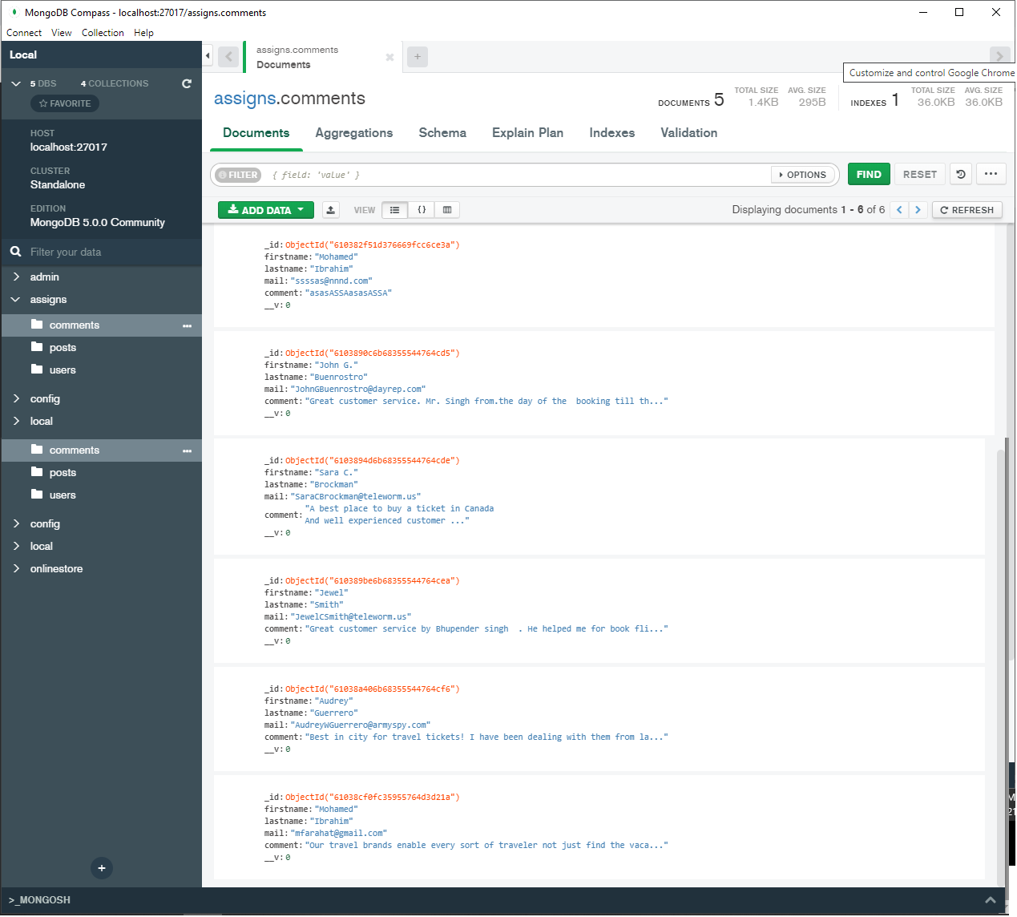

**Assignment 6: MVC and Mongoose**

* Replace your Mongo code with Mongoose code for your contact form.
* Reorganize and refactor your informational website using the MVC pattern.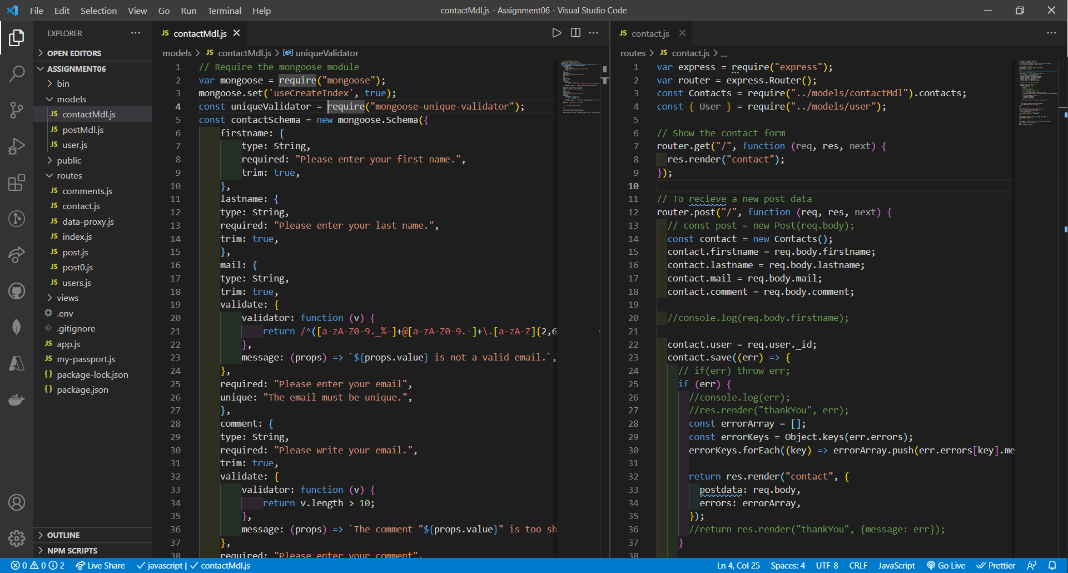
* Validate the ﬁelds in your contact form and display errors.

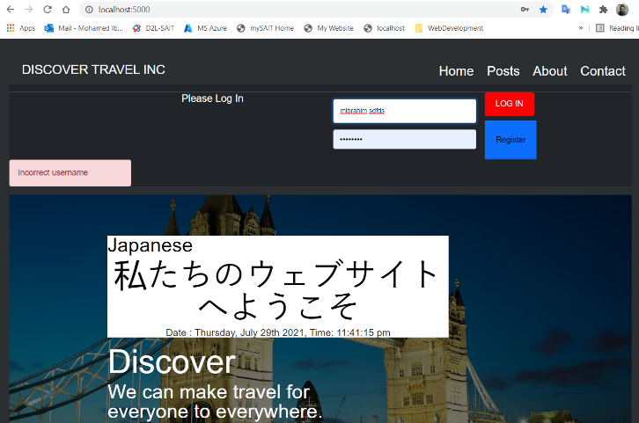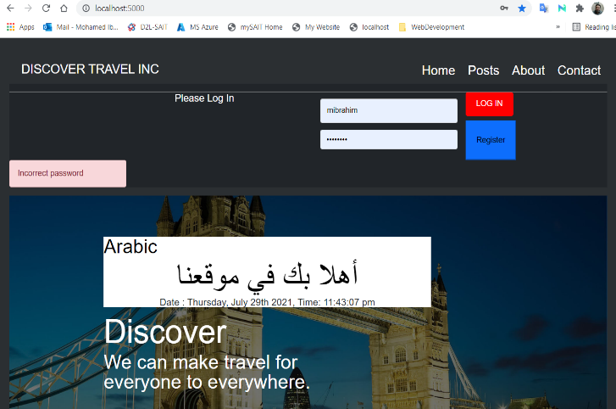

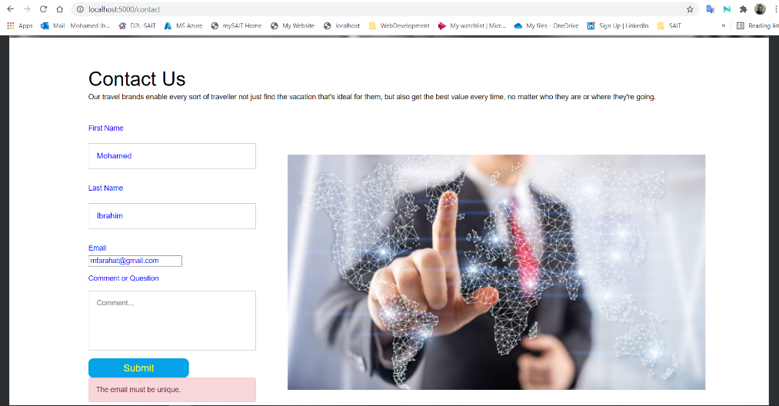

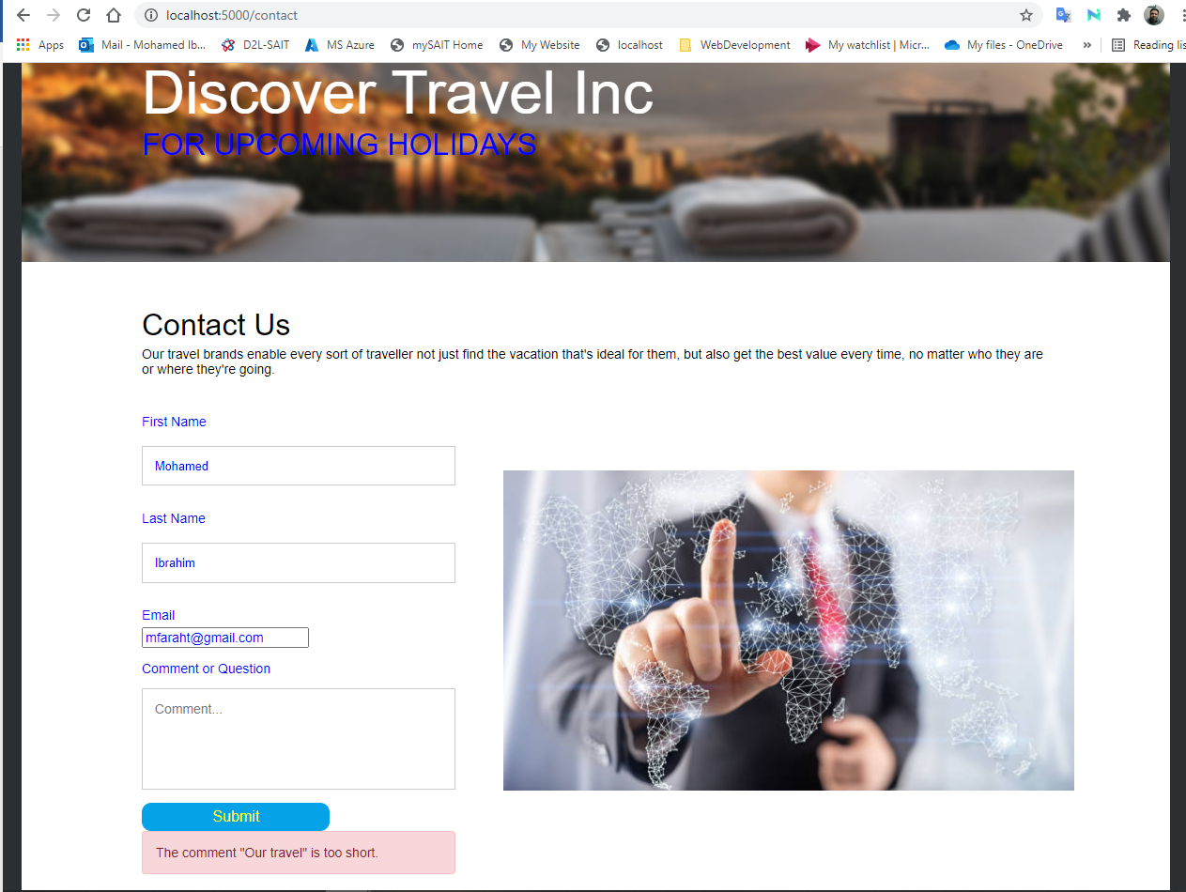

* Redirect to a thank you page and thank the person by name.

